Cloud architecture with google cloud

# Week 1

## Course introduction

* When you look at Google Cloud, you'll see that it's actually part of a much larger ecosystem. This ecosystem consists of open-source software, providers, partners, developers, third-party software, and other Cloud providers.
* Now, Google Cloud consists of Chrome, Google devices, Google Maps, Gmail, Google Analytics, G-Suite, Google Search, and the Google Cloud Platform.
* GCP itself is a computing solution platform that really encompasses three core features
* Infrastructure
* Platform
* software

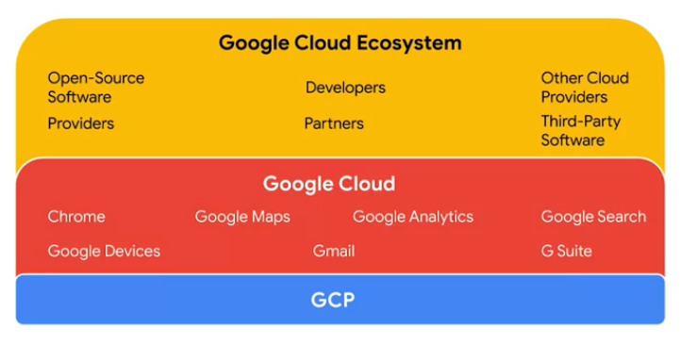

* This map represents GCP's global Infrastructure.
* Connects over 60 zones to over a 130 points of presence through a global network of fiber optic cables.
* GCP uses state of the art software defined networking and distributed systems technologies to host and deliver your services around the world.
* These technologies are represented by a suite of Cloud-based products and services that is continuously expanding.

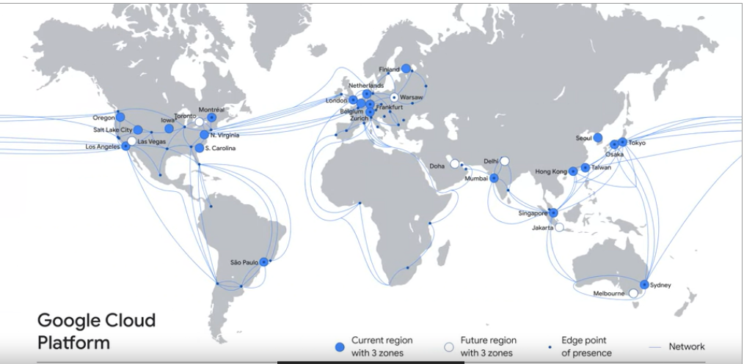

* Many of the products and services are represented by unique blue hexagonal logos such as the ones shown here.

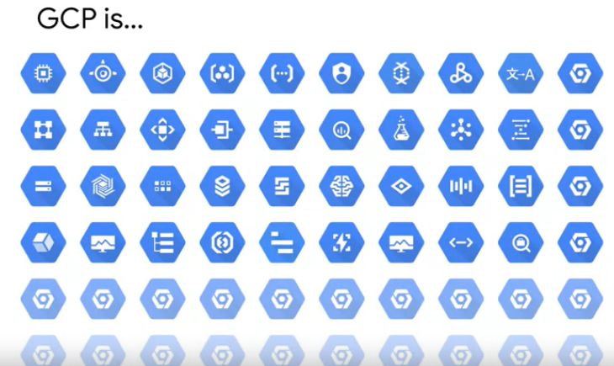

* there is usually more than one solution for a task or application in GCP.
* Let's look at a solution continuum.
* You really can build applications on GCP for the web or mobile that are global, auto-scaling, assistive, and it provides services where the infrastructure is completely invisible to the user

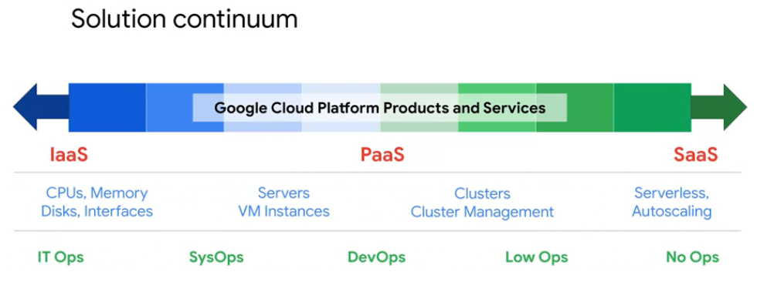

* Google has opened all of these services that make these products possible and package them for your use.
* Alternative solutions like
* For example, you could start up your own VM in Google Computer Engine, Install Open Source MySQL on it and run it just like a MySQL database on your own computer in a data center.
* Or you could use the Cloud SQL service which provides a MySQL instance and handles operational work like backups and security patching for you using the same service as Google does to automate backups and patches.
* You could even move to a NoSQL database that is auto-scaling and serverless.So that growth no longer requires adding server instances or possibly changing the design to handle the new capacity.
* IT infrastructure is like a city infrastructure. The infrastructure is the basic underlying framework of fundamental facilities and systems such as transport, communications, power, water, fuel, and other essential services. The people in the city are like users and the cars and bikes and buildings in the city are like applications. Everything that goes into creating and supporting those applications for the users is the infrastructure.

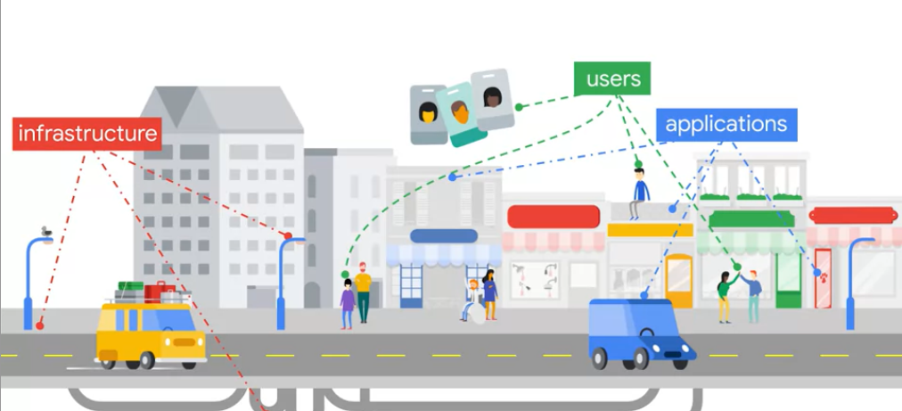

* GCP offers a range of Compute services.
* The service that might be most familiar to newcomers is Computer Engine, which lets you run virtual machines on demand in the Cloud. It's Google Cloud's Infrastructure as a Service solution.It provides maximum flexibility for people who preferred a managed server instances themselves.
* Google Kubernetes Engine lets you run Container as applications on a Cloud environment that Google manages for you under your administrative control. Think of containerization as a way to package code. This design to be highly portable and to use resources very efficiently and think of Kubernetes as a way to orchestrate code in Containers.
* App Engine is GCP's fully managed Platform as a service framework, that means it's a way to run code in the Cloud without having to worry about Infrastructure. You just focus on your code and let Google deal with all the provisioning and resource management.
* Cloud Functions is a completely serverless execution environment or Functions as a Service. It executes your code in response to events whether those events occur once a day or many times per second. Google's scales resources as required, but you only pay for the service while your code runs.

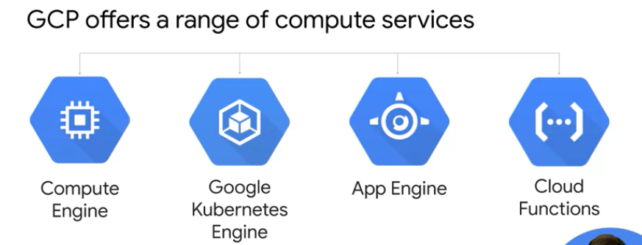

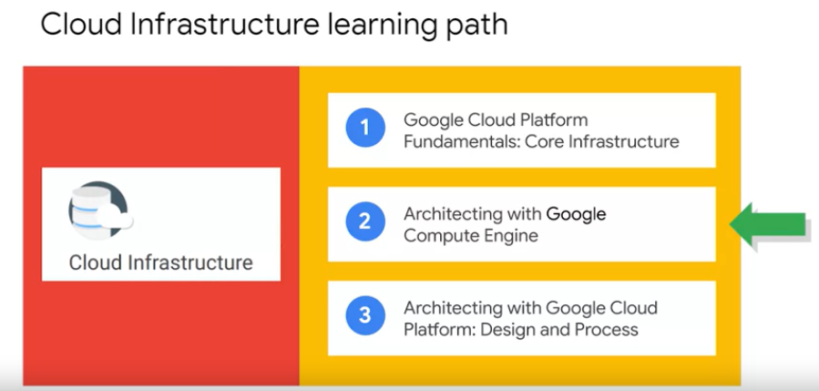

* Essential Cloud Infrastructure foundation is the first course of the architecting with Compute Engine series. In that course, we start by introducing you to GCP and how to interact with the GCP Console and Cloud Shell. Next we'll get into virtual networks and you will create VPC networks and other networking objects. Then we'll take a deep dive into Virtual Machines and you will Create Virtual Machines using Compute Engine.

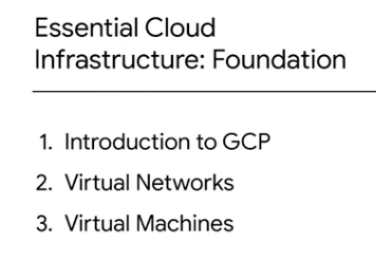

* Essential Cloud Infrastructure Core service is the second course of this series, and that course we start by talking about Cloud IAM and you will administer Identity and Access Management for resources. Next, we'll cover the different data storage services in GCP and you will implement some of those services. Then we'll go over resource management, where you are managed and examined billing of GCP resources. Lastly, we'll talk about resource monitoring and you will monitor GCP resources using Stackdriver services.

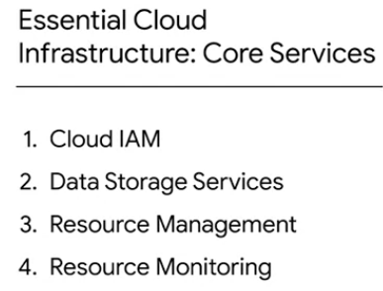

* Elastic Cloud Infrastructure Scaling and Automation is the last course of this series. In that course, we start by going over the different options to Interconnect networks to enable you to connect your infrastructure to GCP. Next we'll go over GCP is load balancing and auto-scaling services which you will get to explore directory. Then we'll cover Infrastructure Automation services like Deployment Manager and terraform so that you can automate the development of GCP infrastructure services. Lastly, we'll talk about other managed services that you might want to leverage in GCP.

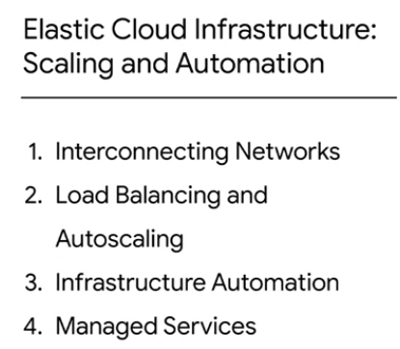

* **Now, our goal for you is to remember and understand the different GCP services and features and also be able to apply your knowledge, analyze requirements, evaluate different options, and create your own services.**

## Module overview

* We will be covering virtual networks.
* GCP uses a software-defined network that is built on a global fiber infrastructure. This infrastructure makes GCP one of the world's largest and fastest networks.
* In this module, we start by introducing virtual private cloud or VPC, which is Google's managed networking functionality for your cloud platform resources
* Then we dissect networking into its fundamental components which are projects, networks, subnetworks, IP addresses, routes and firewall rules, along with network pricing.

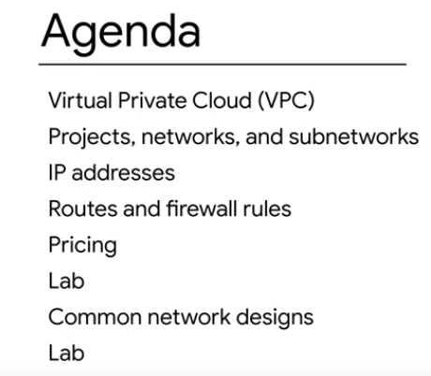

* Next, you will explore GCP's network structure in a lab by creating networks of many different varieties and exploring the network of relationships between them.
* The network connects regions and PoPs and it's composed of a global network of fiber optic cables with several submarine cable investments.

## Using GCP

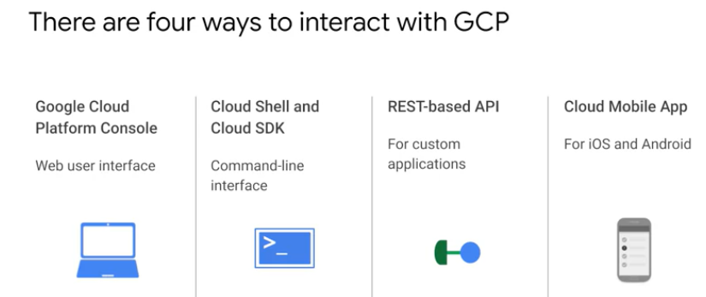

## Lab: Console and Cloud Shell

* There are two integrated environments: a GUI (graphical user interface) environment called the GCP Console, and a CLI (command-line interface) called Cloud Shell.

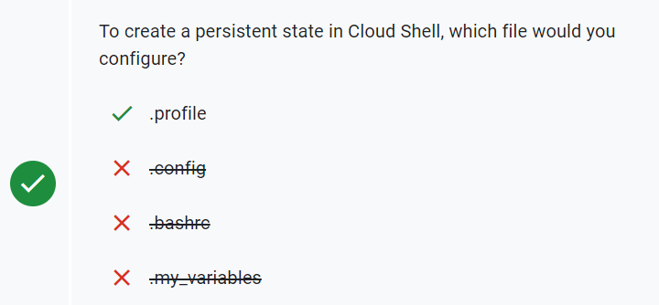

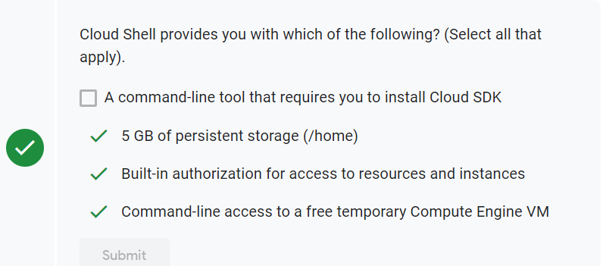

## Infrastructure preview lab

you build a sophisticated deployment(action of bringing resources in effective action) in minutes using Marketplace. This lab shows several of the Google Cloud infrastructure services in action and illustrates the power of the platform.

In this lab, you learn how to perform the following tasks:

* Use Marketplace to build a Jenkins Continuous Integration environment.
* Verify that you can manage the service from the Jenkins UI.
* Administer the service from the Virtual Machine host through SSH

Jenkins is an open source automation server that helps you automate the building, testing, and deployment of any project across multiple platforms. Jenkins helps to avoid breaking changes so that you can save time and ensure the delivery of high-quality software. Its web interface provides an easy way to manage and test your applications before taking them to production. This image bundles the latest versions of community-recommended plugins, including pipelines and Git integration. This open source solution is packaged by Bitnami.